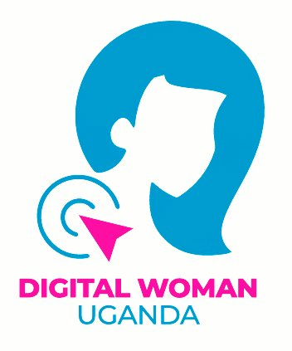

**Digital Woman Uganda (DWU) Reseach Project Report to DHRLab**

**Project Title: Advocacy for Structuring Protective systems for women and children on line**

**Period (March-October 2021)**

**Introduction and Executive Summary**

Digital Woman Uganda (DWU) is a Civic-Tech and Digital Rights Advocacy Organization that was established to provide digital literacy skills to women and girls in urban and rural areas, preparing them to be competitive and self-sustaining in the digital world, advocate for the rights of women and girls in accessing and using the internet and other digital tools to benefit equally from opportunities provided by the new digital tools in this digital world.

DWU received funding from Digital Human Rights Lab in March 2021 to support a project called Structuring Protective Systems for Women and Children on line. The project was planned to be implemented in a period of 8 months.

The main goal of the project was to advocate for the design of policies /systems/laws that would protect women and children while they are using the internet. The project did this by undertaking a number of advocacy interventions that aimed at raising awareness and engaging policy makers and other relevant stake holders on the need to structure protective policies/systems for women and children on line. The advocacy interventions included the following:

A project inception meeting was conducted by the project team to understand how the project would be implemented and to clarify on any issues that were not clear from the project management team. The review of the cyber policies and other children policies was conducted to identify if there were gaps in policies that relate to protecting women and children on line. The gaps identified were packaged into a policy brief with recommendations on how to address the gaps in policies. The cyber policy review report and policy brief were disseminated to policy makers, CSOs, media and any other organization relevant in protecting women and children on line. The subsequent on-line advocacy activities were conducted that included twitter chats and webinars and targeted policy makers, children organization, schools, women organization, government institutions such as ministry of ICT and UCC. The project team also attended regular check in meetings for updates and guidance.

1. **Back ground**

The world at large has witnessed an increase in the access and use of the internet. This situation is no different from Uganda, statistics from Ministry of ICT and National Guidance indicates that there are over 18.8 million internet users. In 2020 and 2021 Internet access increased by 14% and Internet penetration stood at 26.2% in 2021 January. The increase also happened with the Covid-19 lock down where most of the physical work was transferred from off line to online. Women and children also went on line to enjoy the benefits provided by the internet such shopping, education, employment, networking etc. The increase in access and use of Internet resulted in other on-line risks that affected women and children such as online intimidations, cyber bullying, cyber stalking, hate speech, threats, and doxing.

Though the government of Uganda set up legal frame work and policies to protect persons accessing and using the internet, the policies put in place do not explicitly address challenges experienced by women and children while on line. Most of the legal frame works put in place are general and not specific on violence issues that experienced by women and children.

Some of these existing legal instruments and frameworks such as the 2011 computer misuse Act, the data protection and privacy act 2019 and the regulation of interception of communication Act of 2010 have been used by the government to stifle freedom of expression, association and rights of access to information. The case for women and children is even worse due to limited digital literacy and online safety skills or competence making majority of them susceptible to the impact and burdens of online violence.

The project was formulated and planned to address the challenges experiences by women and children while they are using the internet, by advocating and raising awareness on the need to put in place policies/legal frame works that will protect women and children while they are using the internet. The current existing policies/frame works had gaps and were not protecting women and children from the violence experienced on line. This was addressed by conducting a desk research to review the existing cyber policies and children to identify gaps/clauses that protected women and children while they are online. The gaps identified were compiled into a report and a policy brief, disseminated to the policy makers and relevant stakeholder to raise awareness on the issues and gain support for the need to draft policies that protect women and children on line.

1. **Approach**

The challenge was addressed through advocacy. Advocacy involved raising awareness on the online violence experienced by women and children. The lack of specific policies/legal frame works that were tackling tech related violence / violence experienced by women and children on line. The need for crafting new policies and putting in place measures/ legal frame works that would protect women and children while they access and use the internet.

However, this advocacy could not be reliable without having data to back up the identified challenge. The project conducted an evidenced based research where the relevant cyber policies and policies protecting children were reviewed and analyzed for policy gaps/ implications and recommendations compiled into a report and a policy brief to be used for further advocacy/awareness raising and seeking support from policy makers and other relevant stake holders. Twitter charts and webinars were conducted to raise more awareness and reach out to a wider audience.

1. **Narrative report and Output level**

***Please describe the activities that took place, an over view can also be helpful here. Please explain the output of the activities (who participated, what was produced? etc.***

The project implemented the following activities

1. **Inception meeting**

The Project received funding in March 2021. Implementation begun with an inception meeting that was held at Smiles Hotel in Kireka, Wakiso district on 29th March 2021. It was attended by 4 project team members. The purpose of the meeting was to enable the project team understand how the project will be implemented. The meeting clarified issues raised that were not understood from the project kick off meeting that was held with the Project Manager from better place lab. The meeting helped the team to brainstorm and come up with a list of cyber policies / ICT policy documents that were to be reviewed and ICT stakeholders the project was to work with. A detailed report of what transpired from the inception meeting was compiled and submitted to the Project Manager, better place lab.

1. **Cyber policy review report compilation**

The exercise for compiling the Cyber policy review report was undertaken in the month of April and May 2021. The review exercise begun with identifying the Consultant to support the activity, designing the Terms of Reference (TORS) for the Consultant, identifying the policies to be reviewed, engaging the Consultant to review the policy documents and compilation of the report. A number of policy documents identified and reviewed included: the Computer Misuse Act, Data Protection and Privacy Act, The Regulation of Interception of Communication Act 2010, Access to information Act 2005, Children’s Act (2016) CAP 59 as amended, The Penal Code Act Cap 120 Chapter 14, section 128,(3), Section 144, Section 148, The Uganda National Parenting Guidelines 2018 by Ministry of Gender, Labor and Social Development and The National Child Policy Implementation Plan 2020/21 – 2024/25 strategy 3.3

The review process was supported by two persons from the project team and by the end of April 2021 the research team had produced the first draft of the cyber policy review report. The draft report was submitted for review and comments to the Project Manager at better place-lab. Comments were received and incorporated in the report and a revised copy produced. The report was further submitted for more input to Encrypt Uganda and to the Projects focal person in Uganda. The final revision and edits were done and a final approved copy produced.

During the draft report review process, the need to have the report redesigned with graphics arose to make it look better. The issue was discussed with the Project Manager at better place-lab and he agreed to support the report redesign process. The graphic designer was identified and a contract drafted. The contract was submitted to the Project Manager for approval. The graphic designer was engaged and the Cyber Policy Review Report was redesigned and produced.

1. **Production of a policy brief from the Cyber Policy review report**

Preparation of the Policy brief begun with identification of the Consultant. The Terms of Reference (TORs) were developed and shared with her. A contract was drafted and shared with her for approval. She agreed to undertake the assignment by signing the contract. The process of compiling the policy brief was initiated by sharing with her the Cyber policy report. The Consultant submitted the draft policy brief and it was shared with the Project Manager of better place lab for comments and input. The Comments were received and incorporated by the Consultant. The policy brief was also redesigned with graphics to make it look better and presentable. A final redesigned copy was produced and submitted to be printed by Mars Printing Company Limited.

1. **Dissemination of the policy brief and report findings through webinars**

This activity was originally planned to happen by having a physical workshop of 25 persons. But due to the Covid-19 pandemic that affected the country and caused the government of Uganda to institute a second lock down, led to a change in plan where the in-person gathering were turned into online webinars. The decision to hold the two on line webinars on dates 12th and 13th August 2021 was agreed upon during the monthly check in meeting for the month of June 2021.

The two webinars targeted different stake holders, the webinar conducted on 12th targeted Policy makers, CSOs, Academicians whereas the webinar conducted on 13th targeted media persons. In the two webinars two key presentation were made i.e. Cyber Review report and the Policy brief. The policy brief highlighted major policy gaps and recommendations made for Structuring Protective Systems for women and children on line.

Participants from the two webinars raised concerns that included:

* The need to sustain political advocacy by continuously engaging political leaders to include the policy recommendations raised in the policy making processes.
* The need to do more advocacy for taxes to be reduced (12% levy on data) If internet was to be accessed by all people both in urban and rural areas.
* Uganda Communication Commission represented by Mr Mwesigwa requested the policy brief be shared with them for further advocacy. UCC also asked the DWU team to come up with a responsibility Matrix on who does what and responsible for what to enable those in authority be held accountable.
* He also mentioned a need to work with the consumer department at UCC

to enable them understand the issues raised the consumers digital services

* UCC urged Digital Woman Uganda to work with them to tackle the issues raised and push the agenda into policy making process.

The participants of the 2nd webinar who were media persons requested that both the cyber policy report and policy brief be disseminated locally using radios to reach out to a wider public and rural people. They also indicated a need to strengthen implementation of Uganda laws, so that they are able to curb cybercrimes.

**Blog Production**

During the dissemination webinars, a blogger/ social media influencer was identified and engaged. She was able to compile a blog which was uploaded on the DWU website.

**Production of Info shares**

In support of the dissemination webinars info shares in form of fliers about the policy review findings and policy gaps were designed and produced and shared on twitter and what’s up groups. This was done by the consultant who redesigned the Cyber Policy Review Report and the Policy Brief.

**V) Conducting online advocacy activities through webinars and twitter chats**

**1st Twitter chat**

The month of September and October were planned to hold on line advocacy activities i.e. twitter chats and the webinars. In September one twitter chat was held on 17th from 11.00 am to 12.00pm. The topic for the discussion was on Cyber policies, protecting women and children online. The chat questions were formulated and a flier circulated on DWU online space (twitter) to raise awareness and call for participation.

The questions included:

* What are some of the online violence women and children face on line?
* What are the policies in place to protect women and children on line? Are they really working to protect those people?
* Do the laws that we have in Uganda infringe on Internet rights
* Why don’t people report on line violations
* What should the government of Uganda do in regard to safety of women and children on line?
* What is the role of Internet service providers in protecting women and children on line?
* What is the role of CSOs in promoting children and women on line safety?

The panellists were identified from Digital Rights related organization that included Digital Literacy Initiative, Her Internet and ISOC Uganda chapter. The twitter chat highlighted some of the online violence’s experienced by women and children, laws in Uganda in Uganda that infringe on Internet rights, the roles CSOs play in trying to keep women and girls safe in online spaces.

On the case of cross border crime, the international community was requested to undertake similar measures to curb on line violence. The discussion also discussed the issue of developing self-esteem among women and girls to help them develop mental stability to help them overcome challenges.

The discussions were held on the twitter space, the twitter space was moderated by a DWU Program staff. The persons who attended the twitter space discussions were 16. The twitter chat reached out to people and on that day 17th September, when the twitter chat was conducted the tweets made impressions and the highest registered was 499. The highest engagement rate was 9.8%. More details can be found in the twitter analytics attached for the month of September.

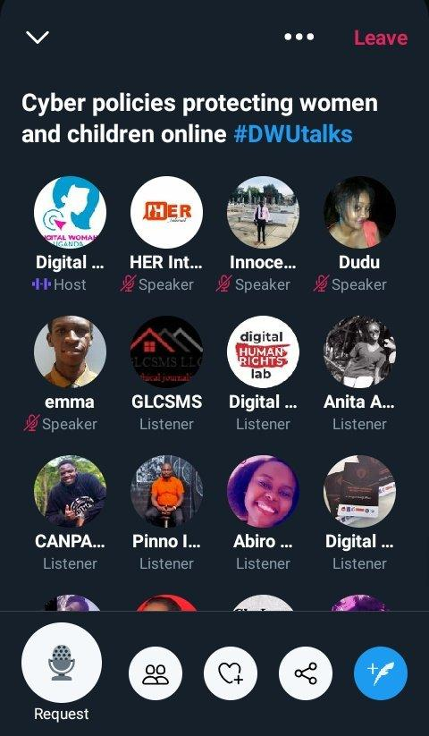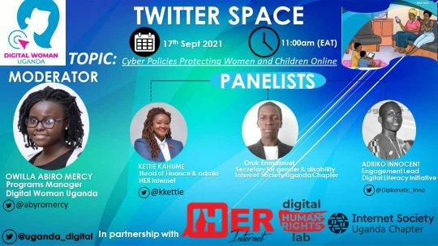

***Screen shots for a twitter chat (find attached on the report  
Twitter analytics are also attached.***

**1st Webinar**

In the month of October, one twitter chat and two webinars were organized. The first webinar was organized and it took place on 7th October and had 26 participants. The Topic discussed was “Children online safety, policy recommendations” The webinar targeted children organization and government institutions in charge of formulating policies for children. Head teachers and teachers of primary and secondary schools were also invited to participate and discuss children on line violence. A flier for the webinar was developed and circulated online.

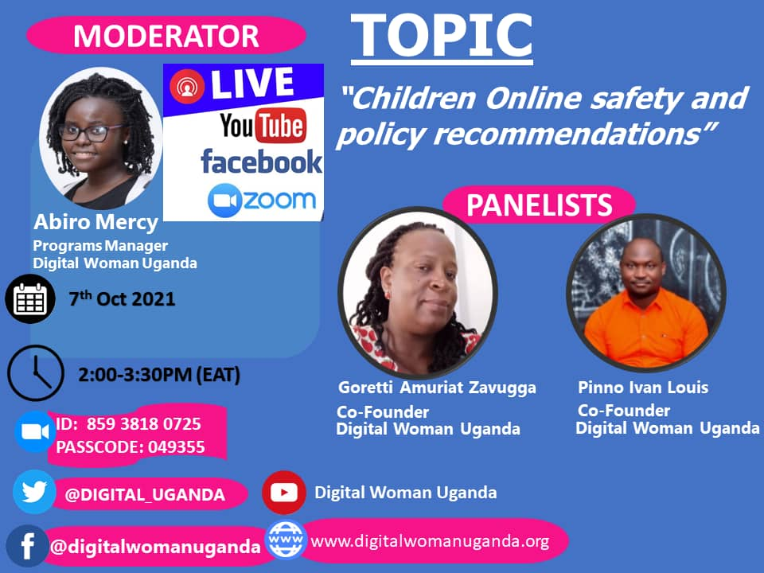

***Flier for webinar***

The webinar had a keynote speaker from Encrypt Uganda who sensitized the participants on the kind of violence being experienced by children on line and the need to promote children online safety. The DWU team member presented the policies available that protect children, the gaps and recommendation. From the discussions among the issues raised was the need for parents and teachers to be part of process of protecting children online. The policies put in place should specifically include clauses that protect children on line. The webinar ended with a call to protect children on line, by sensitizing them on how they can keep safe and how parents can contribute to children on line safety.

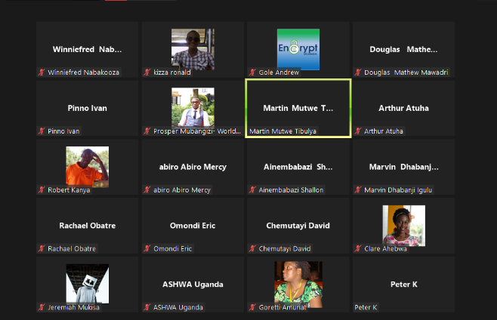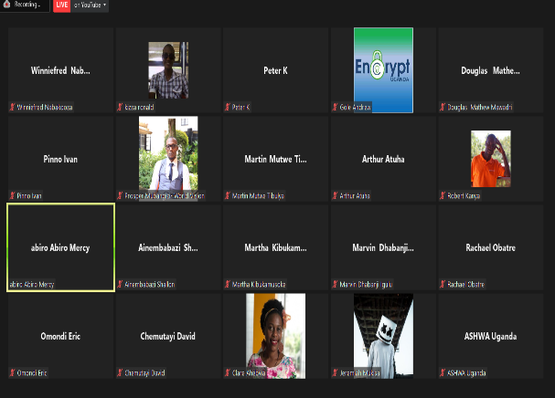

***Screen shots of the webinar (find attached as jpeg)***

**Twitter Chat**

In the month of October one twitter chat was held on 21st October from 11.00 to 12.00pm. The twitter chat topic was; Promoting Children’s on-line safety. The twitter chat flier was developed and shared on DWU on line platforms i.e. twitter, face book and website. The twitter chat was moderated by the DWU Program staff. The lead Panelist were drawn from Digital Literacy Initiative and Her Empire. Below are extracts from the twitter chat.

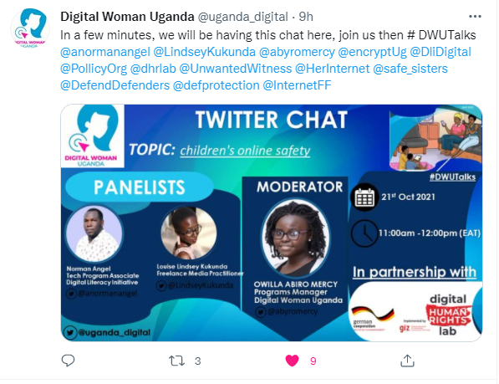

The chat questions developed, shared, discussed included the following:

1. What are the problems children are facing on line?
2. What policies are in place to protect children on line?
3. What roles do CSOs play in online protection of children?
4. Do the online space offer children a chance to enhance their skills?
5. Recommendations in promoting online safety for children.

Below are some of the tweets from the twitter chat discussion.

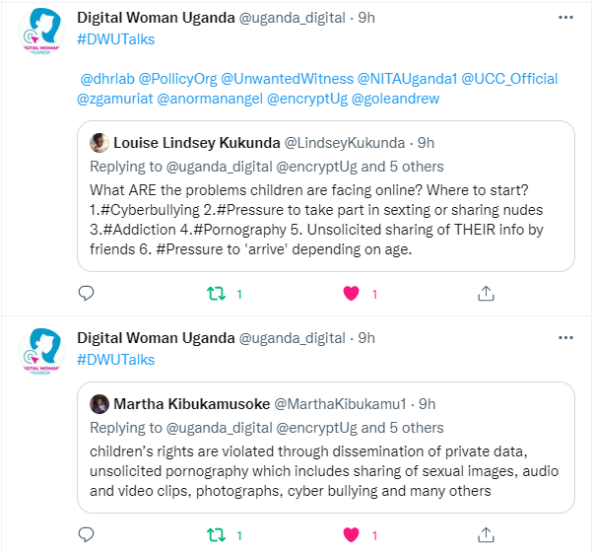

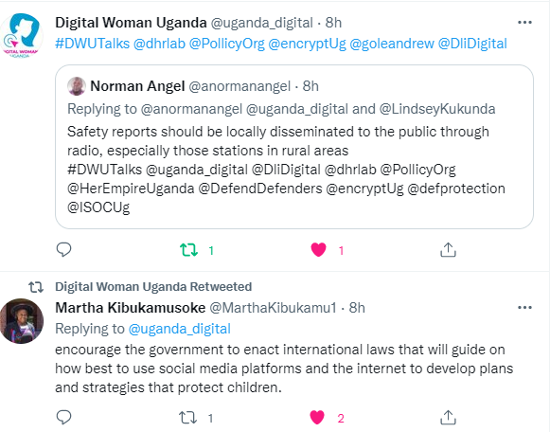

The twitter chats targeted policy makers, institutions working on child related issues and Civil Society Organizations.

The twitter chat raised awareness on violence experienced by children while they are using the Internet. The policies and existing gaps in protecting children on line and recommendations.

From the tweet analytics, the twitter handle @uganda_digital, the tweets reached out and made impressions. By the 29th October, there were 245 likes, 79 retweets and 19 link clicks.

More information can be found in the twitter analytics for October that are attached to this report.

**2nd Webinar**

The second webinar and the last project activity was held on 29th October 2021. This webinar discussed cyber policies protecting women and children on line. The webinar was moderated by the Executive Director, Her Empire and panelist were drawn from Internet Society Uganda Chapter (ISOC) and the Gender Tech Initiative. The flier was developed and disseminated online to raise awareness on the webinar. Invitation letters were written and sent out to over 40 potential participants. The Uganda Women Parliamentarian Association (UWOPA) was contacted, invited to participate. An invitation letter was written and extended to the Executive Director and she promised to ensure six women parliamentarians participate. Unfortunately, the women parliamentarians who were expected to attend the webinar and the Ministry of ICT did not participate. Participation from the key government institution was received from Uganda Communications Commission only. The webinar attracted 19 participants only while those registered and approved were 38.

The webinar raised awareness on the line violence experienced by women and children, cyber policies available, the policy gaps and the need to draft new policies / review current policies to include clauses that protect women and children on line. Recommendations from the webinar included the following:

* The need to strengthen cyber laws that govern the ICT spaces
* Uganda Communication Commission (UCC) need to work with the Ministry of ICT to ensure the cyber policies are implemented
* The need to disseminate study finding widely so that many stakeholders are sensitized.
* The need for CSOs to collaborate with the stake holders that make impact in terms of crafting issues raised into draft policy documents.
* There is need to hold face to face meeting with the policy makers, to hold them accountable on policy gaps and need to craft cyber policies that protect women and children online.
* There is need to compile gender disaggregated data on line violence experienced by women and children. To show how the men and women are violated.

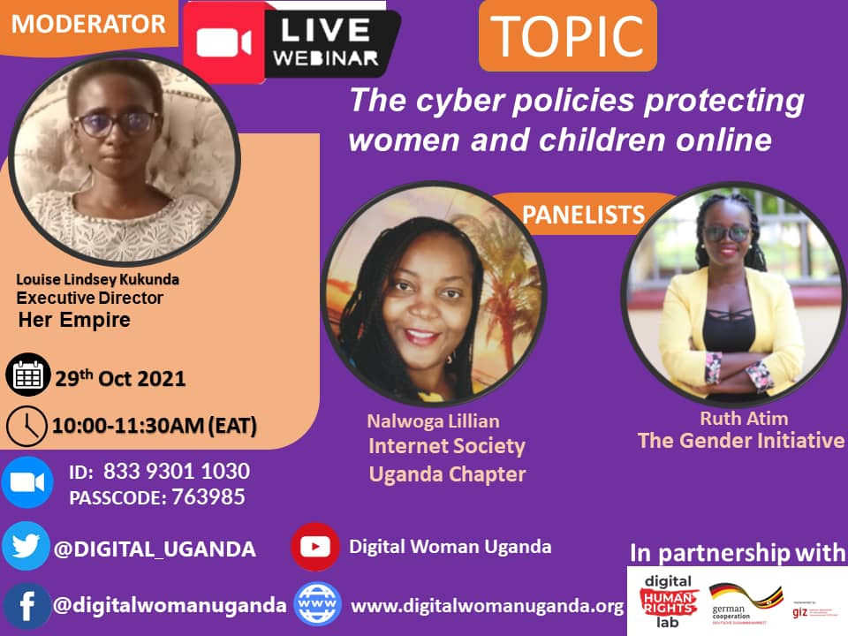 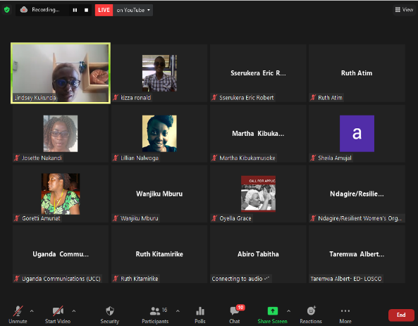

Webinar flier and screen shots. Attached also are the participants lists and screen shot as jpeg

1. **Monthly Check in meetings and reports**

The project team participated in the project monthly check in meetings for all the eight months together with the Project Manager, at better place-lab and the Project focal person in Uganda. In the meetings, updates on the projects were provided by the Project lead and guidance and support received. The project lead also compiled monthly reports and submitted them for review and input from the Project Manager, better place lab. The meetings were very helpful in checking and guiding project implementation.

1. **Designing the M and E Matrix**

Basing on the project proposal and the milestones/ activities that were put in the proposal to be followed during the project implementation process. The Project team held a meeting agreed on developing a detailed monitoring and evaluation frame work for the project. The Frame work based on the project outcomes and indicators that were put in the project proposal. The Mand E frame work was used to measure out puts, out comes using the indicators set.

**5.0 Evaluation**

***Methodology: How did you go about the evaluation (M and E matrix, indicators, sources)***

The project team reviewed the project implementation process by analyzing what the project set out to do from the onset. What was the project objective? What were the targeted out comes and who were involved? To get answers the project team reviewed the Project document, project work plan, monthly project reports compiled and the Monitoring and Evaluation matrix developed.

From reviewing the project document, the project set out to advocate for structuring for protective systems/policies for women and children on line. This was to be done by raising awareness among the policy makers on the need to structure protective systems/laws to protect women and children online. To do this the project was supposed to undertake the following interventions: review the existing cyber policies and children policies, identify policy gaps and package the gaps in policy brief and use the policy findings to advocate for structuring protective systems for women and children online.

***Describe results on outcome level (what did you achieve?)***

From the Project Monitoring and Evaluation Matrix the project expected outcome was increased awareness among policy makers on the need to structure protective systems for women and children on line. This would be measured by the number of policy documents drafted or clauses inserted in the existing policies that specifically address online violence experienced by women and children.

From the analysis the project increased awareness and knowledge among policy makers and other relevant stake holders (CSOs, Media, Academia and Government Institutions). The project conducted awareness raising webinars and tweeter chats where the policy makers such as Uganda Communication Commission (UCC). Ministry of ICT and Women Parliamentarians through UWOPA were invited. The project also produced a cyber policy review report and a policy brief which was shared with Uganda Women Parliamentarians Association (UWOPA), UCC and Ministry of ICT.

The project also conducted Online advocacy activities i.e. twitter chats and webinars, held discussions on the need to structure protective systems for women and children on online. From the twitter analytics, it was observed that the day the twitter chat was held on 17th September the impressions made were 499. On 29th the day we had the last webinar the twitter chat had 245 likes. Implying a good number of people checked out the tweets on the DWU twitter handle @uganda_digital.

Also, it was observed that the people who participated in the webinars i.e. the two dissemination webinars held on 12th and 13th August for policy makers, academicians, CSOs and media were 62 and the number of persons who attended the webinars conducted under advocacy activities were 45 (held on 7th and 29th October 2021).

This implies that the project reached out to new people and made awareness and increased knowledge on the need to structure policies that protect women and children on line.

However, the target where the project was to come up with policy documents/ or articles crafted and inserted in policy documents that protect women and children on line was not achieved. This was constrained by time. Two months of advocacy i.e. September and October were too short for the policy makers to understand the issue being discussed. By the time the project ended there was still need to do more awareness, engage policy makers, to understand and support the issue of protecting women and children by structuring policies that protect women and children online. There was need to carry out more engagements/discussions, have face meetings, make presentations, lobby policy makers to accept the on-line violence issue being discussed. Also, there was need to identify champions to take further the issue and convince fellow policy makers in parliament to support the issue.

Despite, the limited project time line, the project successfully did all the planned interventions in the specified planned project period. The limited time available hindered organizing meaningful campaigns on various media e.g. radios, TVs, and conducting face to face meetings for policy makers. The online advocacy activities conducting were limiting, as most invited participants could not attend because of not having data and lack of knowledge and adaptability to use platforms such as twitter and zoom. The Covid-19 that turned face to face meeting to inline also affected the project implementation.

***How do you rate your success or failure?***

When the project team analyzed the project implementation, putting in consideration the project interventions and their time lines. The project successfully implemented at least 90% of all the planned activities within the time frame set. The only activity that was not done was participation in draft policy committees. This activity could not be achieved because it was an external activity, the project team had no control over it. It depended on when the draft policy committee meetings were organized and happened. During the project period there was no policy draft committee meeting held.

At output level the project produced 90% of the out puts targeted. It only fell short on participating in the draft policy committees. At output level the project produced almost all the targeted out puts.

On Outcome level, the project increased awareness and knowledge on the need to structure protective systems for women and children on line among the policy makers, CSOs, academicians and Government institutions. However, the project fell on not having policy makers draft protective policies/put protective systems in place that protect women and children on line. In this we rate the project to have achieved 50% to 50%.

*If possible include graphics to support your evaluation statements*

**6.0 Lessons learned**

From the project implementation experience these were some of the learnings made:

**What went well**

* The project team managed to implement all the project activities in the planned project period of 8 months
* The project was able to identify gaps in cyber policies available and children policies, made recommendations on structuring protective systems for women and children on line
* The project compiled a cyber policy review report and a policy brief which will be used for more subsequent advocacy activities. The documents were disseminated online on the DWU website and @uganda_digital.
* The project raised awareness on the need to put specific policies that address violence experienced by women and children while they are accessing and using the internet.
* The project was able to bring various stakeholders including those in the Non- government space to engage in dialogue and see how we can collaborate to make the internet eco-space safe for all.
* The project produced two documents the cyber policy review report and the policy brief
* The resources were spent within the specified budget lines.

**What didn’t go well?**

* The policy makers were invited for webinars and did not attend the online webinars
* There was failure to identify the right people to attend the webinars. Those who attended most webinars were not the right persons who were responsible for drafting protective policies for women and children on line.
* There was failure to have policy makers draft policies that protect women and children on line given the project time period that was very short. The project ended when these issues have not been discussed by policy makers.
* The Covid-19 Pandemic that turned physical meetings to online meetings and limited in person gathering. Most of the discussions held were done online and this had a disadvantage of not seeing face to face the people you are engaging.
* The funds available were very small to support the advocacy activities. For instance, it could not support data for MPs and other participants
* The planned online activities could not cover many stakeholders. Those who were not Internet users were left out

**What would have been done differently**

* Advocacy needs more time if you are to achieve concrete results. In planning for the advocacy events, you have more time to mobilize the participants, invite them early to enable them plan to attend the event.
* Advocacy is not a onetime event, this a continues process. But it needs to be supported with more resources to enable meetings happen and participation in policy discussions, and engaging policy makers.
* When doing advocacy, you need to use various channels bot one, so as to target more beneficiaries/policy makers. For instance, some policy makers can be reached through online activities, others radio, TV and other by face to face meetings. So more advocacy channels must be planned and budgeted to reach out to many targeted people.
* Also, there is need to identify champions/influencers who will champion your advocacy cause and influence other to accept your position.
* There is need to support advocacy activities with enough resources
* For the advocacy efforts initiated to achieve expected results/ outcomes of drafting policies that protect women and children online, the project has to be supported and be extended to sustain the advocacy efforts initiated.

**7.0 Conclusion**

In all the project implementation process went on well and the project was able to be completed in the set time line. However, being that the project was an advocacy project more time was needed to raise awareness and engage policy makers on the issues identified so that the issues are supported and incorporated in policy documents. The process of advocacy initiated need to continue to ensure that the policies that protect women and children are crafted and put in place so that the women and children enjoy their rights as they access and use the internet.