

**Project Report Enhancing digital literacy for the Digital inclusion COP members and University girls in Pallisa District for safe access and effective utilization of digital tools**

1. **Introduction**

Digital Woman Uganda is a civic tech and digital rights organization that was established to provide digital literacy skills to women and girls both in urban and rural areas, preparing them to be competitive and self-sustaining in the digital world, advocate for the rights of women and girls in accessing and using the internet and other digital tools to benefit equally from opportunities provided by the new digital tools in this digital world.

Digital Woman Uganda on behalf of the Digital Inclusion COP was contracted to undertake a short-term project titled “Enhancing digital literacy for the Digital Inclusion COP members and University girls in Pallisa District for safe access and effective Utilization of Digital Tools. The main objective of the project was to build capacity of Digital Inclusion (COP) members and Busitema University girls in Digital literacy.

**The specific objectives were**

* Train trainers (TOT) to support training of the Digital Inclusion COP members and Busitema University girls.
* Equip the Digital inclusion COP with skills in online safety, creation of online digital footprints and effective use of social media for advocacy and dissemination.
* Equip the Busitema University girls with skills in online safety, effective use of social media for advocacy, learning, research and dissemination
* Document the digital literacy training experience in Kampala and in Pallisa and compile a report for sharing with partners.

**The project expected results were**

* 6 Trainers trained and are able to train other the Digital inclusion members who will not be able to participate in the initial training.
* Digital inclusion COP members acquire skills in online safety, creation of online digital foot prints and effective use of social media in advocacy and dissemination.
* Busitema University girls acquire knowledge in online safety and application of digital tools in development/ education and learning
* A report compiled on the training activity and shared with partners.

The project activities were:

* Conduct a one-day online training of trainers through zoom for six participants identified from the Digital Inclusion COP membership and from Busitema University girls. The training will be done for 8 hours from 8am to 5pm
* Conduct an online training through zoom, for the digital inclusion COP members for one day, for four hours from 9am- 1pm for 25 persons
* Conduct an in-person training meeting for two days for the University girls in Busitema Pallisa district for 4 hours per day (9am-1.00 pm) for 25 people.
* Compile activities undertaken into a report for sharing with partners.

1. **Status of Project implementation:**

Digital literacy trainings were organized by Digital Woman Uganda. on behalf of the Digital Inclusion COP. The trainings took place in Kampala and Pallisa. The Kampala activities were held on line and the Pallisa activity conducted physically. Digital Woman Uganda developed fliers which were also shared online to advertise the trainings. These activities conducted included:

**2.1 A one-day online training of trainers in digital security**

A one-day training of trainers in digital security was conducted on 11th February 2020 on line through a Zoom platform. Participants were selected from Digital Inclusion COP members. The training was facilitated by an organization called Her Empire and it was attended by 6 participants. They included:

1. Nakazibwe Aminah from Freedom and Roam
2. Akello Faimah form National Association of Police
3. Atehe Olga from Freedom and Roam
4. Martha Kibukamusoke from Digital Woman Uganda
5. Harriet Adong from Athena Girls Compound
6. Muwonge Gerald from Foastee Foundation for Health Care Uganda.

The training covered the following topics and sub topics:

1. Risk management

* Malware and on fact checking of breached sites using haveibeenwned,com
* Avoid online breaches e.g. disabling browser, storing of passwords
* Avoid Malware on your device
* Protecting your contacts

1. Digital protection and privacy

* The very basics
* Phishing
* Social engineering
* Data back up
* The Down side of Notification

1. Password management

* Choosing a face password
* Using a password Manager
* Test run: Is your password safe
* Social engineering

1. Tools used to enhance training

* Menti-meter
* Jam Boards
* Kahooti

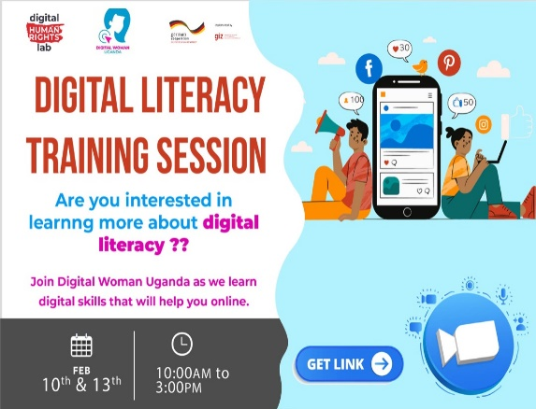

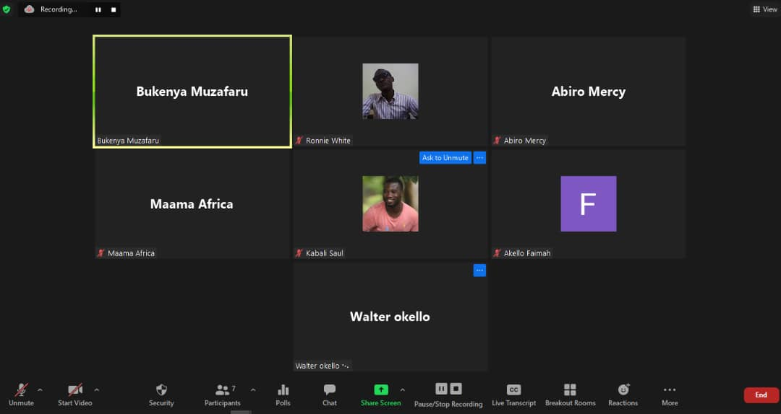

**Screen shots of the Training of Trainers conducted and fliers developed**

**2.2 Conduct an online digital security training through zoom, for the digital inclusion COP members for one day, for four hours from 9am- 1pm for 25 persons**

The digital security training training-workshop took place on 13th February 2022 and was held online, starting at 10:00am – 1:30pm. The participants started logging on by 9:56am and training started at 10.15am. The trainer/facilitator was Ms. Diana Namanda supported by the DWU staff

The 4-hour online training-workshop covered the following topics:

* Device Hygiene – power point attached
* Privacy Setting – We looked at one application (gmail) and referred to other applications like WhatsApp, Facebook etc.
* Secure Communication – We discussed how we can communicate using secure platforms and using open source tools like Tor browser etc.
* Lastly, we discussed Mobile Security – Power point attached.

The online training-workshop was attended by about twenty (20) participants comprising of journalists, civil society, human rights defenders and IT officers coming from digital inclusion COP members. The training-workshop was opened with introductions where participants got to know each other

However, the zoom page organized could not share presentations, which made the trainer migrate and use another platform (google meet) that made sharing easy and did not limit on time and number of of participants who were attending the training. The facilitator tried to engage the participants by calling their names to give in their opinions on different topics as the training went on.

The breaks were made every after an hour and took 5 – 7 minutes. The trainer tried to get participants engaged by calling on their names and asking them to give opinions on different topics.

**At the end of the training** Some participants said the training was good. It helped them acquire new knowledge on digital security. Participants requested to be given the power point presentation, and it was sent to those who submitted in their emails.

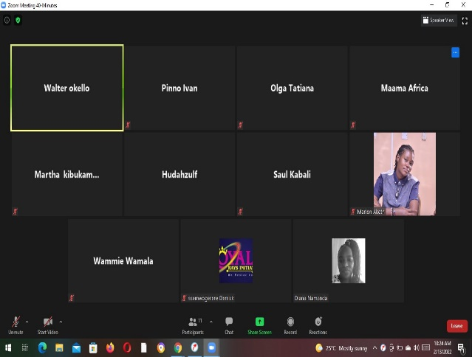 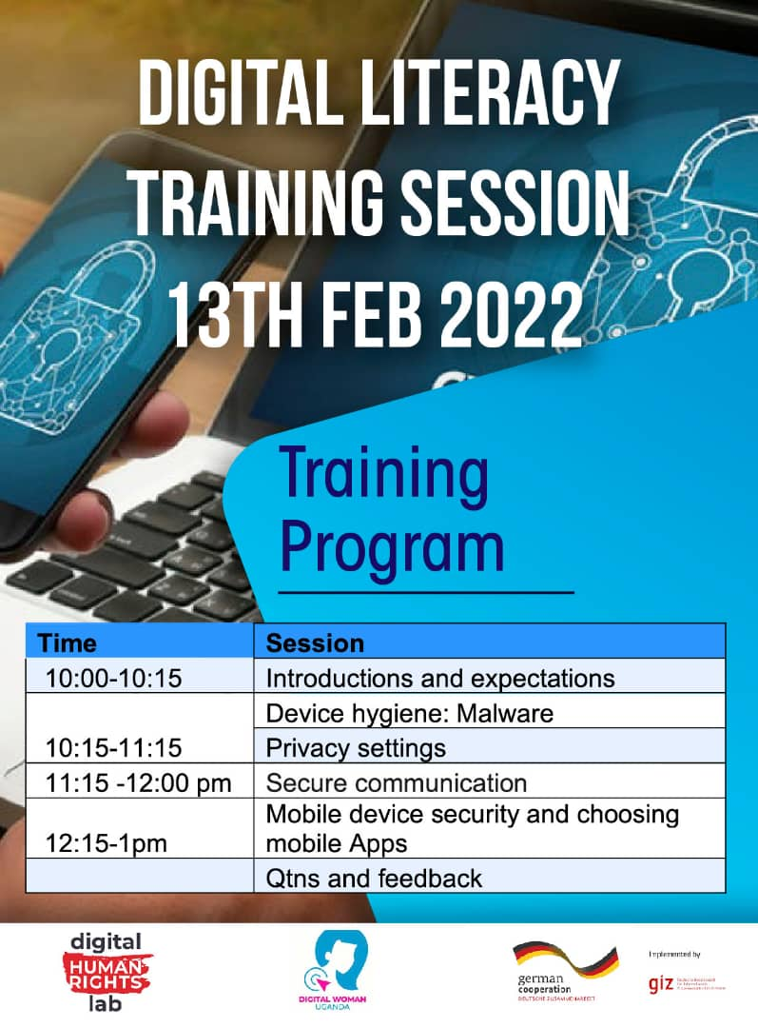  
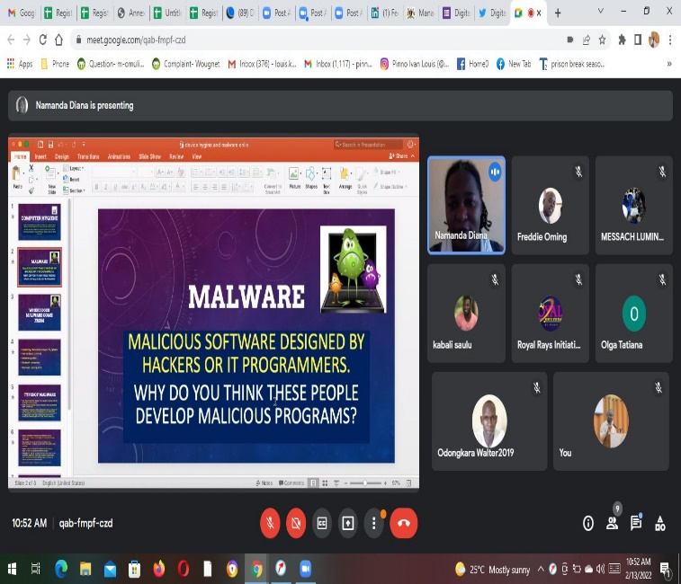

**Screen shots for the on-line training for the COP members**

**2.3 Conduct an in-person training meeting for two days for the University girls in Busitema Pallisa**

The training was conducted in Pallisa at Busitema University on dates 21st abd 22nd February 2022. It was attended by 25 students from the University. The training covered online safety, safe browsing, Safe Digital foot prints, Hard ware Clinic (how to keep safe your gadgets) on line social media and communication channels. The training went on well, participants appreciated the training that was conducted. From the training workshop participants expressed a need for more training, students felt the time planned for it and days were not enough. They requested for more trainings to be provided and more students to be involved as well. More time for practical skills training was needed as most students requested for more hands-on training.

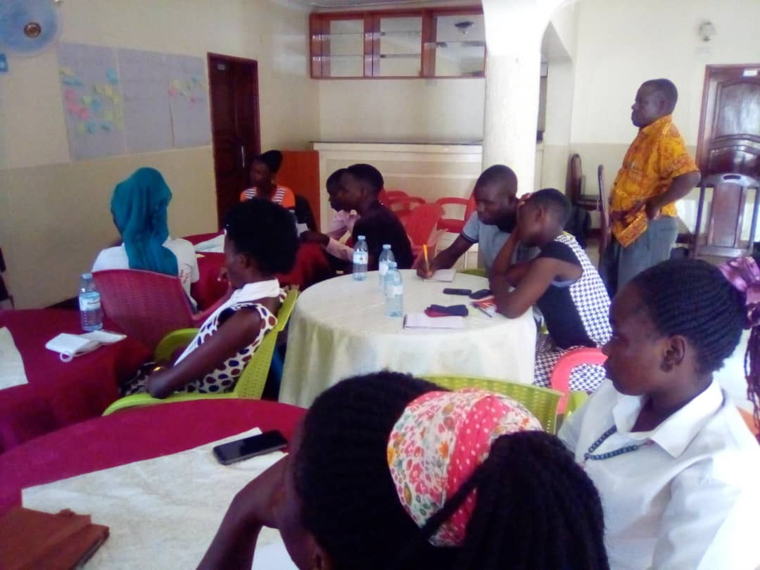 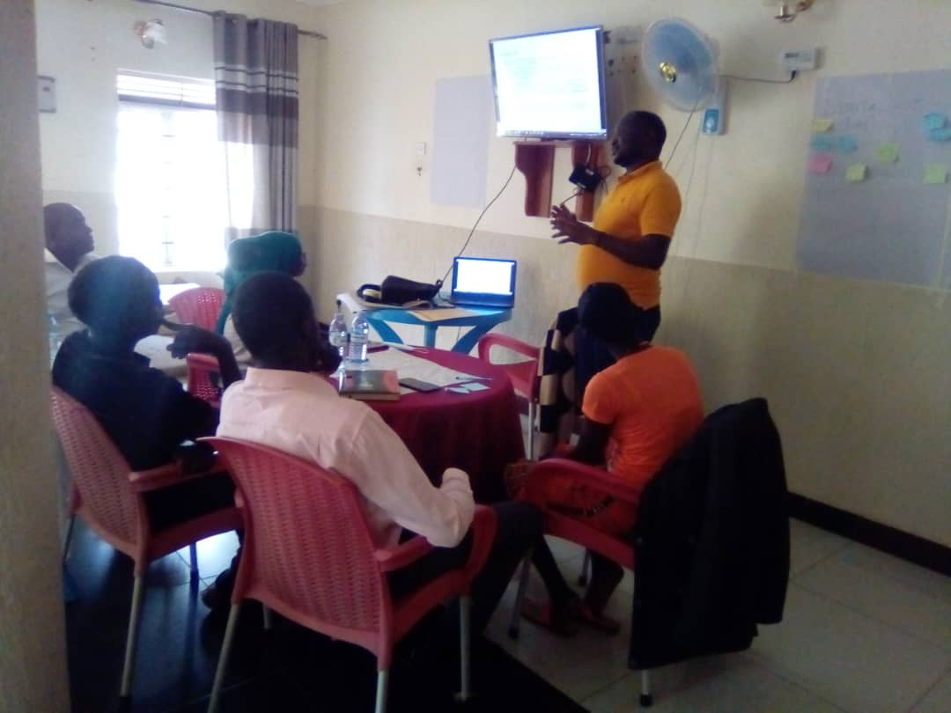

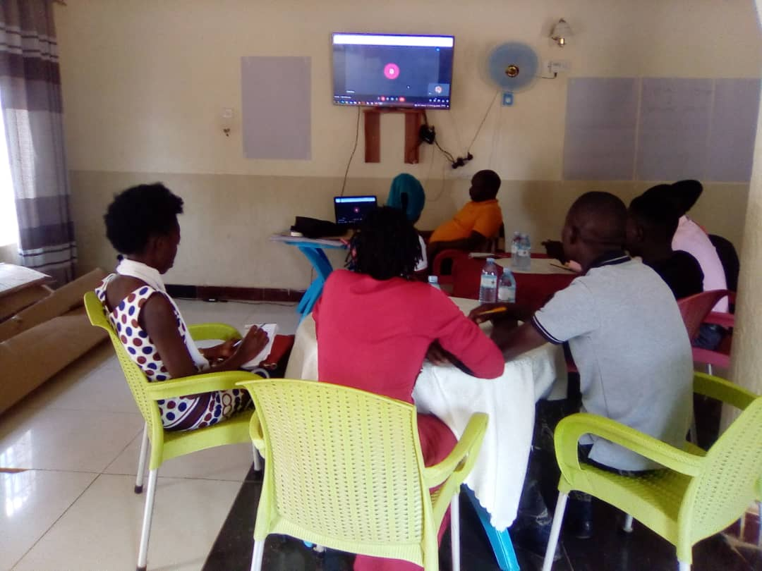 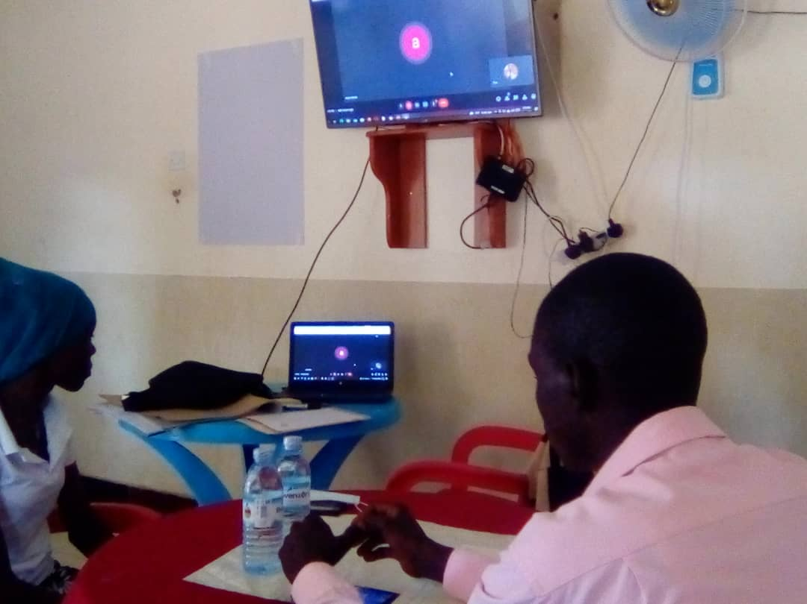  
Pictures for the digital literacy training conducted in Pallisa

1. **Achievements**

The training equipped Digital Inclusion COP members and Busitema University girls with knowledge and skills in digital safety skills (6 trainers, 20 COP members and 25 Busitema University girls). The training raised awareness on the need to keep safe on line and equipped the students with practical skills on how to keep safe as they access and use the internet.

1. **Challenges**

* The hours allocated for the online training activity for the COP members was not enough, the participants requested for more time to be provided next time.
* The online activity for the COP members was planned to happen on Sunday, and this affected effective participation, participants had to choose between going to church and attending the training.
* The Kuchu Times (Member of the COP) who were supposed to be partners on the project implementation were not available which led to identification of new partners to support the training.
* The budget was very limited and could not support many members of the digital inclusion COP to take part in project implementation.
* Most University girls lacked access to computers and smart phones on which to apply the skills. This limited their uptake of skills
* The digital security training are much more informative if held physically, On line training limit exchange and physical touch of digital tools

1. **Recommendations**

* The number of girls who got opportunity to be part of the training was small compared to those that were in need. More training be conducted in digital security for the University girls at Busitema University, Pallisa. District.
* The digital security training conducted for the COP members, time allocated was not enough. Also, the mode of training through zoom does not allow practice of skills give. This is better done in a physical meeting Next time such training to be conducted should be held in physical setting and sessions be allocated more time to allow participants to learn and be guided in the skills provided.
* The University girls requested for such training in digital literacy to be conducted regularly, to enable more girls acquire knowledge on how they can keep safe online.
* Institutions such as Universities based in rural districts to provide computer rooks where students can access computer, internet practice and be able to practice the skills given.

1. **Conclusion**

The digital literacy trainings conducted both online and offline for the Digital inclusion COP members and University girls in Pallisa went on well and equipped participants with online safety skills so as to help them keep safe as they access and use the Internet. University girls expressed a need for more and regular training to enable more students acquire skills in digital safety given that now most of the teaching and learning is being done online. The project also built capacity of 6 Trainers and these trainers will support subsequent digital security training organized by the COP